SEOUL BIKE RENTALS
December 2017 Rental Analysis
Daily, hourly, weekly and weather patterns, with three recommendations

Summary
Seoul Bike Rentals recorded 185,330 rentals in December 2017, a mean of 5,978 per day. Demand fell as the month went on. Mean daily rentals dropped 43% from Week 1 (8,220) to Week 3 (4,695) and rose by 14% in Week 4 (5,334). Week 4 remains 35% below Week 1.

Total Rentals  185,330 | Mean per Day  5,978 | Busiest Day  9,539  Fri 1 Dec | Quietest Day  2,014  Sun 4 Dec | Week 1 to Week 3  -43%

- Hours. Weekday rentals peak at 8:00 and 18:00, which points to commuting. Weekends peak in the afternoon.
- Days. Friday is the strongest weekday at 7,923 rentals per day. Sunday is the weakest at 3,978.
- Weather. Temperature shows a weak link with daily rentals (r = +0.10). Days with rain or snow ran lower. Snowfall peaked in Week 3. The sample is 31 days, so the report treats this as a lead and not a proof.
- Evidence limits. The data holds no bike availability, repair, fleet or revenue records. The recommendations test causes and do not assume them.

Data Audition and Definitions

Data Audit
The audit checked the December 2017 slice of the source file before any analysis.
Check | Results
Source file | SeoulBikeData.csv, 8,760 hourly rows from 1 December 2017 to 30 November 2018
Records in scope | 744 rows, which equals 31 dates × 24 hours
Hours per date | 24 on every date
Missing values | 0
Duplicate rows | 0 (no repeated date and hour pair)
Closed hours (Functioning Day = No) | 0, so every hour counts as operating
Rentals per hour | Lowest 3, highest 937
Season label | Winter on all 744 rows
Holiday flag | The source flags 22, 24, 25 and 31 December as holidays. This report treats 25 December as the only public holiday and classes the other three dates by weekday or weekend.

Data Definitions
Term | Definitions
Week | Runs Friday to Thursday. Week 1 starts on Friday 1 December 2017. Week 5 holds three days (29 to 31 December).
Mean rentals per day | Total rentals divided by days in the period. The report uses this to compare weeks, since Week 5 is partial. Weekly totals would mislead.
Weekend | Saturday and Sunday.
Holiday | Monday 25 December 2017.
Time blocks | Night 0 to 5, Morning 6 to 9, Midday 10 to 15, Evening 16 to 20, Late 21 to 23.
Peak-to-trough drop | (Highest day − lowest day) ÷ highest day.
Wet day | Any day with rainfall or snowfall recorded.
Correlation (r) | Runs from −1 to +1. The value r² gives the share of variation explained.

Business Questions and Findings
Question 1: How did daily rentals move in December 2017 and which days stand out?
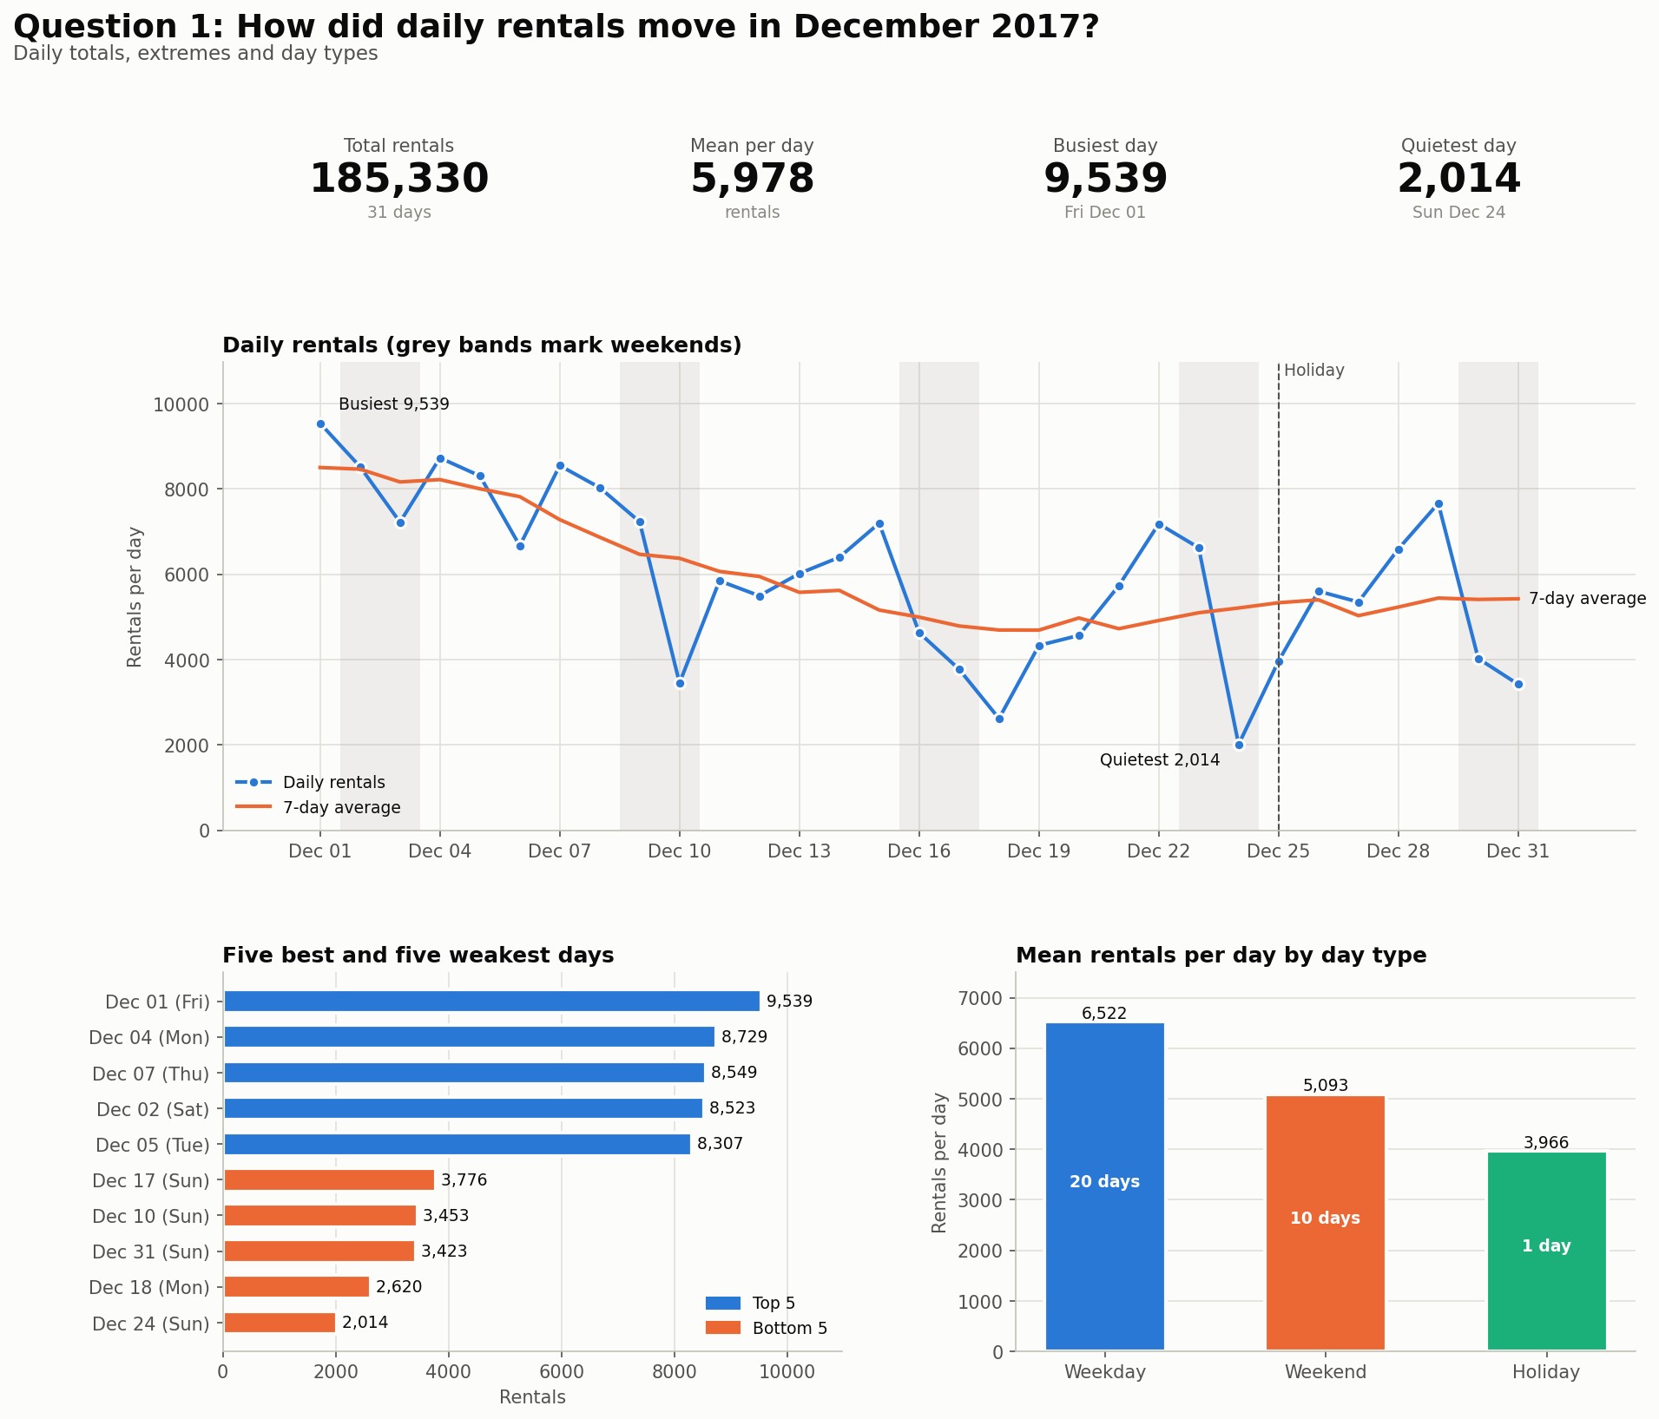
Figure 1. Daily Rentals, December 2017.
- December 2017 had 185,330 rentals over 31 days, a mean of 5,978 per day.
- The busiest day was Friday 1 December with 9,539 rentals. The quietest was Sunday 24 December with 2,014.
- The peak-to-trough drop is 79% (9,539 to 2,014). Two days set this figure, so the figure shows range and not direction.
- Days 1 to 15 averaged 7,148 per day. Days 16 to 31 averaged 4,882, a drop of 32%.
- Weekend days averaged 5,093 rentals against 6,522 on weekdays, a gap of 22%.
- Christmas Day (Monday 25 December) recorded 3,966 rentals, 31% below the mean of the other Mondays (5,732).]
Answer. Rentals started high and weakened through the month. Sundays hold the lowest points.
Question 2: What does a typical day look like by hour and when are the peaks?
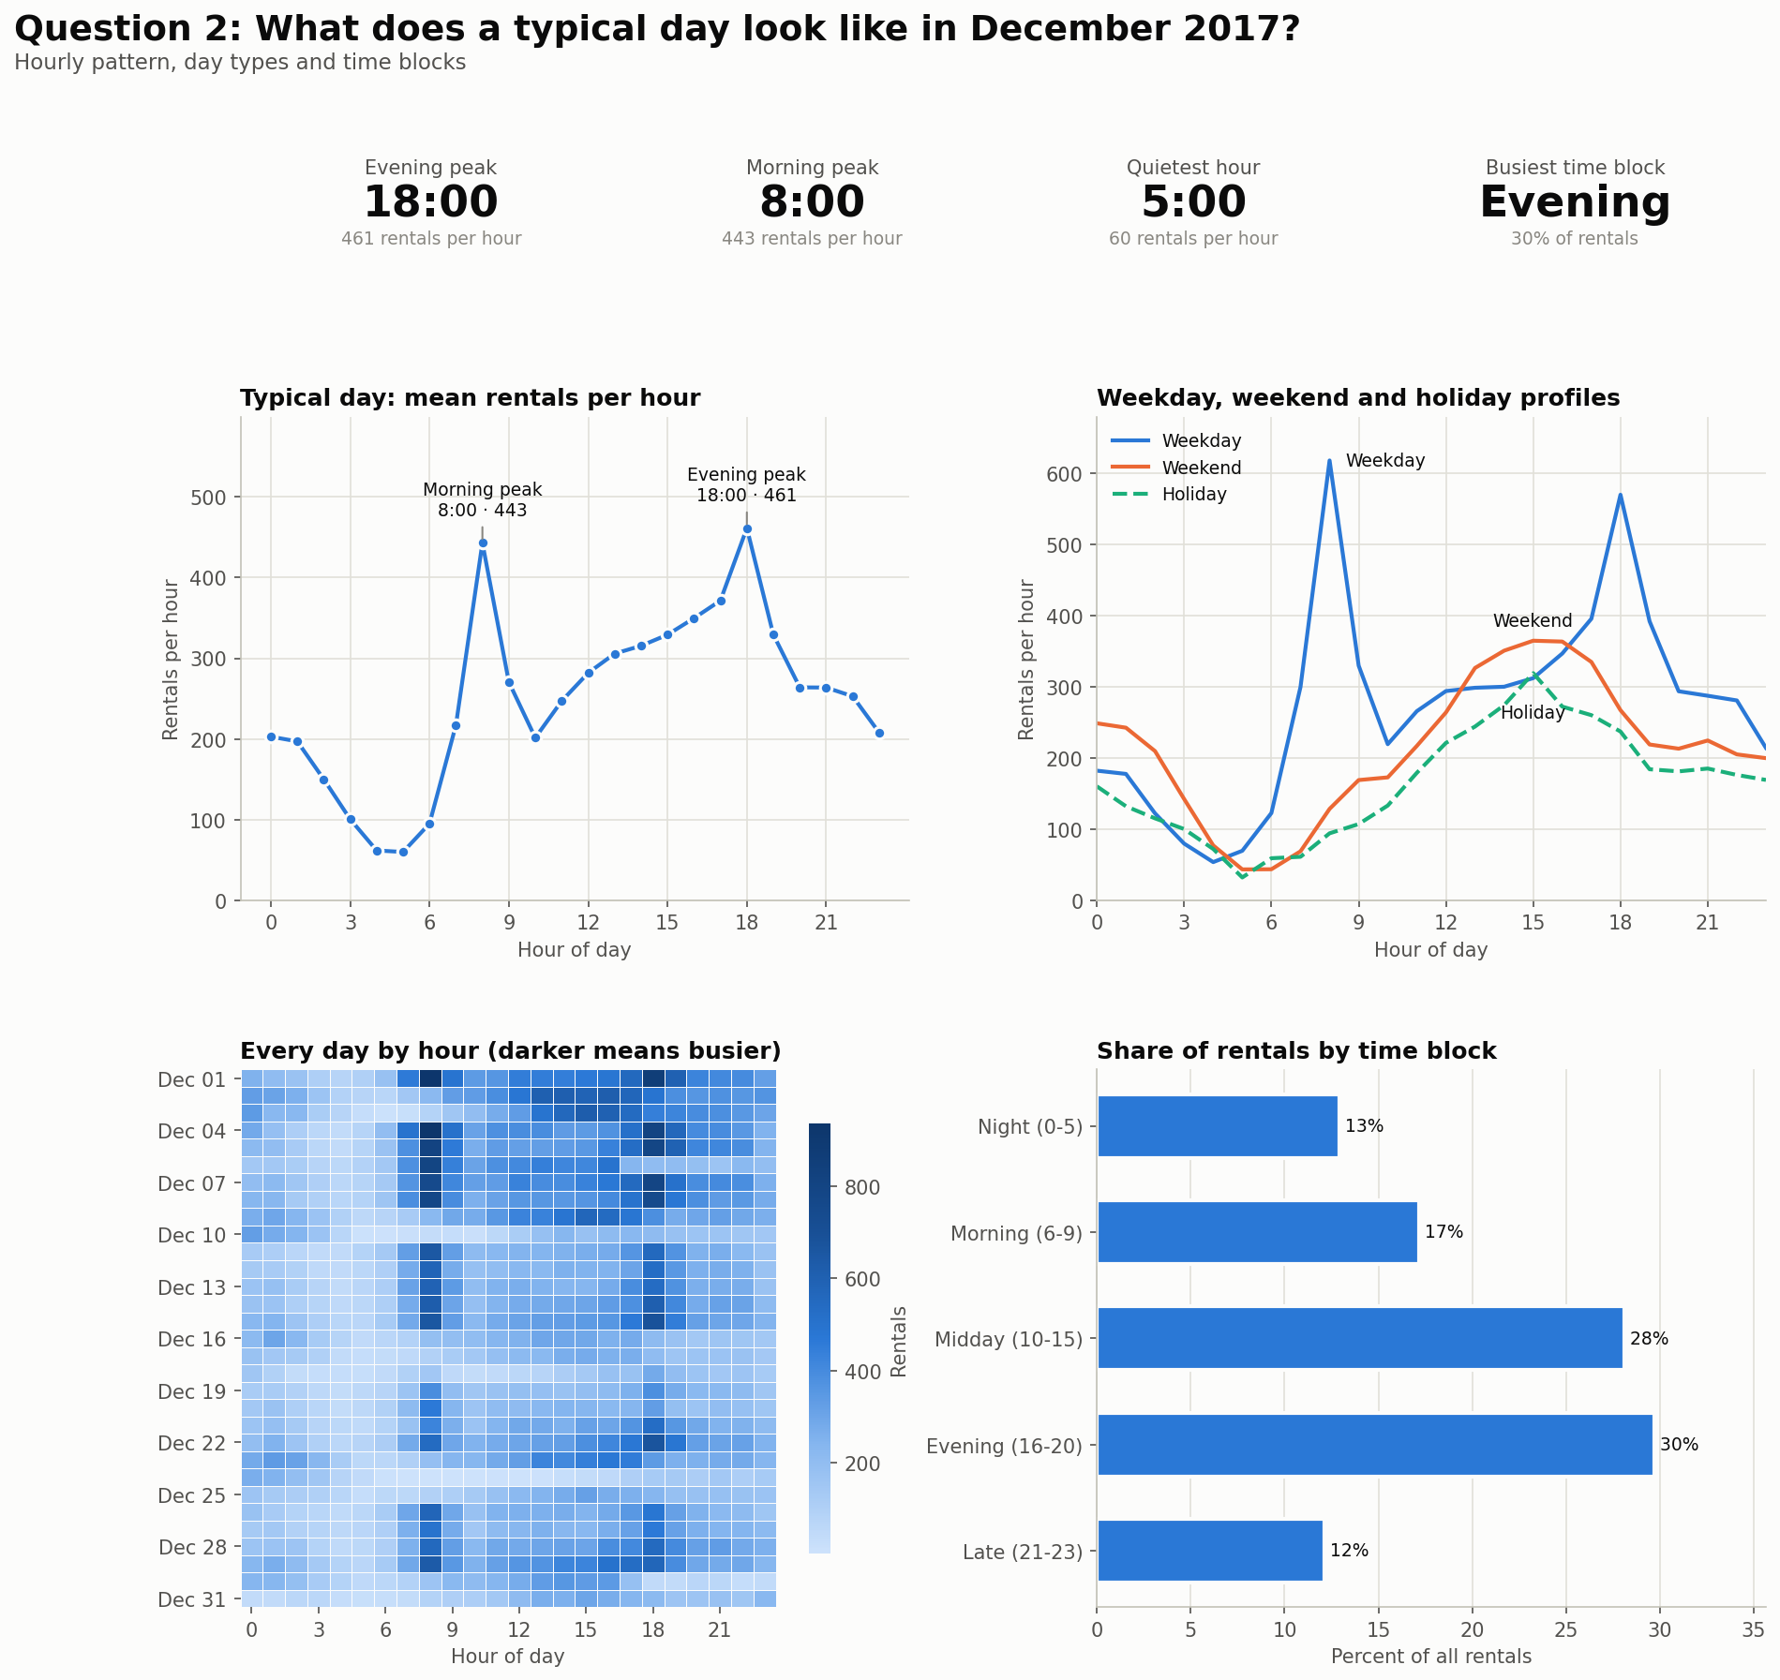
Figure 2. Rentals by hours, by day_type.
- Across all days, the evening peak is 18:00 at 461 rentals per hour and the morning peak is 8:00 at 443. The quietest hour is 5:00 at 60.
- Weekdays peak at 8:00 (618 per hour) and 18:00 (570). Weekends peak at 11:00 (217) and 16:00 (363). The holiday peaks at 11:00 (179) and 16:00 (272).
- At 8:00, weekday rentals run 4.8 times the weekend rate.
- On all 20 weekdays other than the holiday, the busiest hour was 8:00 (15 days) or 18:00 (5 days).
- The evening block (16:00 to 20:00) holds the largest share of rentals at 30%.
Answer. Weekdays show two commuter peaks. Weekends show one afternoon rise. The shapes differ enough to split the profile by day type.

Question 3: How do weeks and weekdays compare?
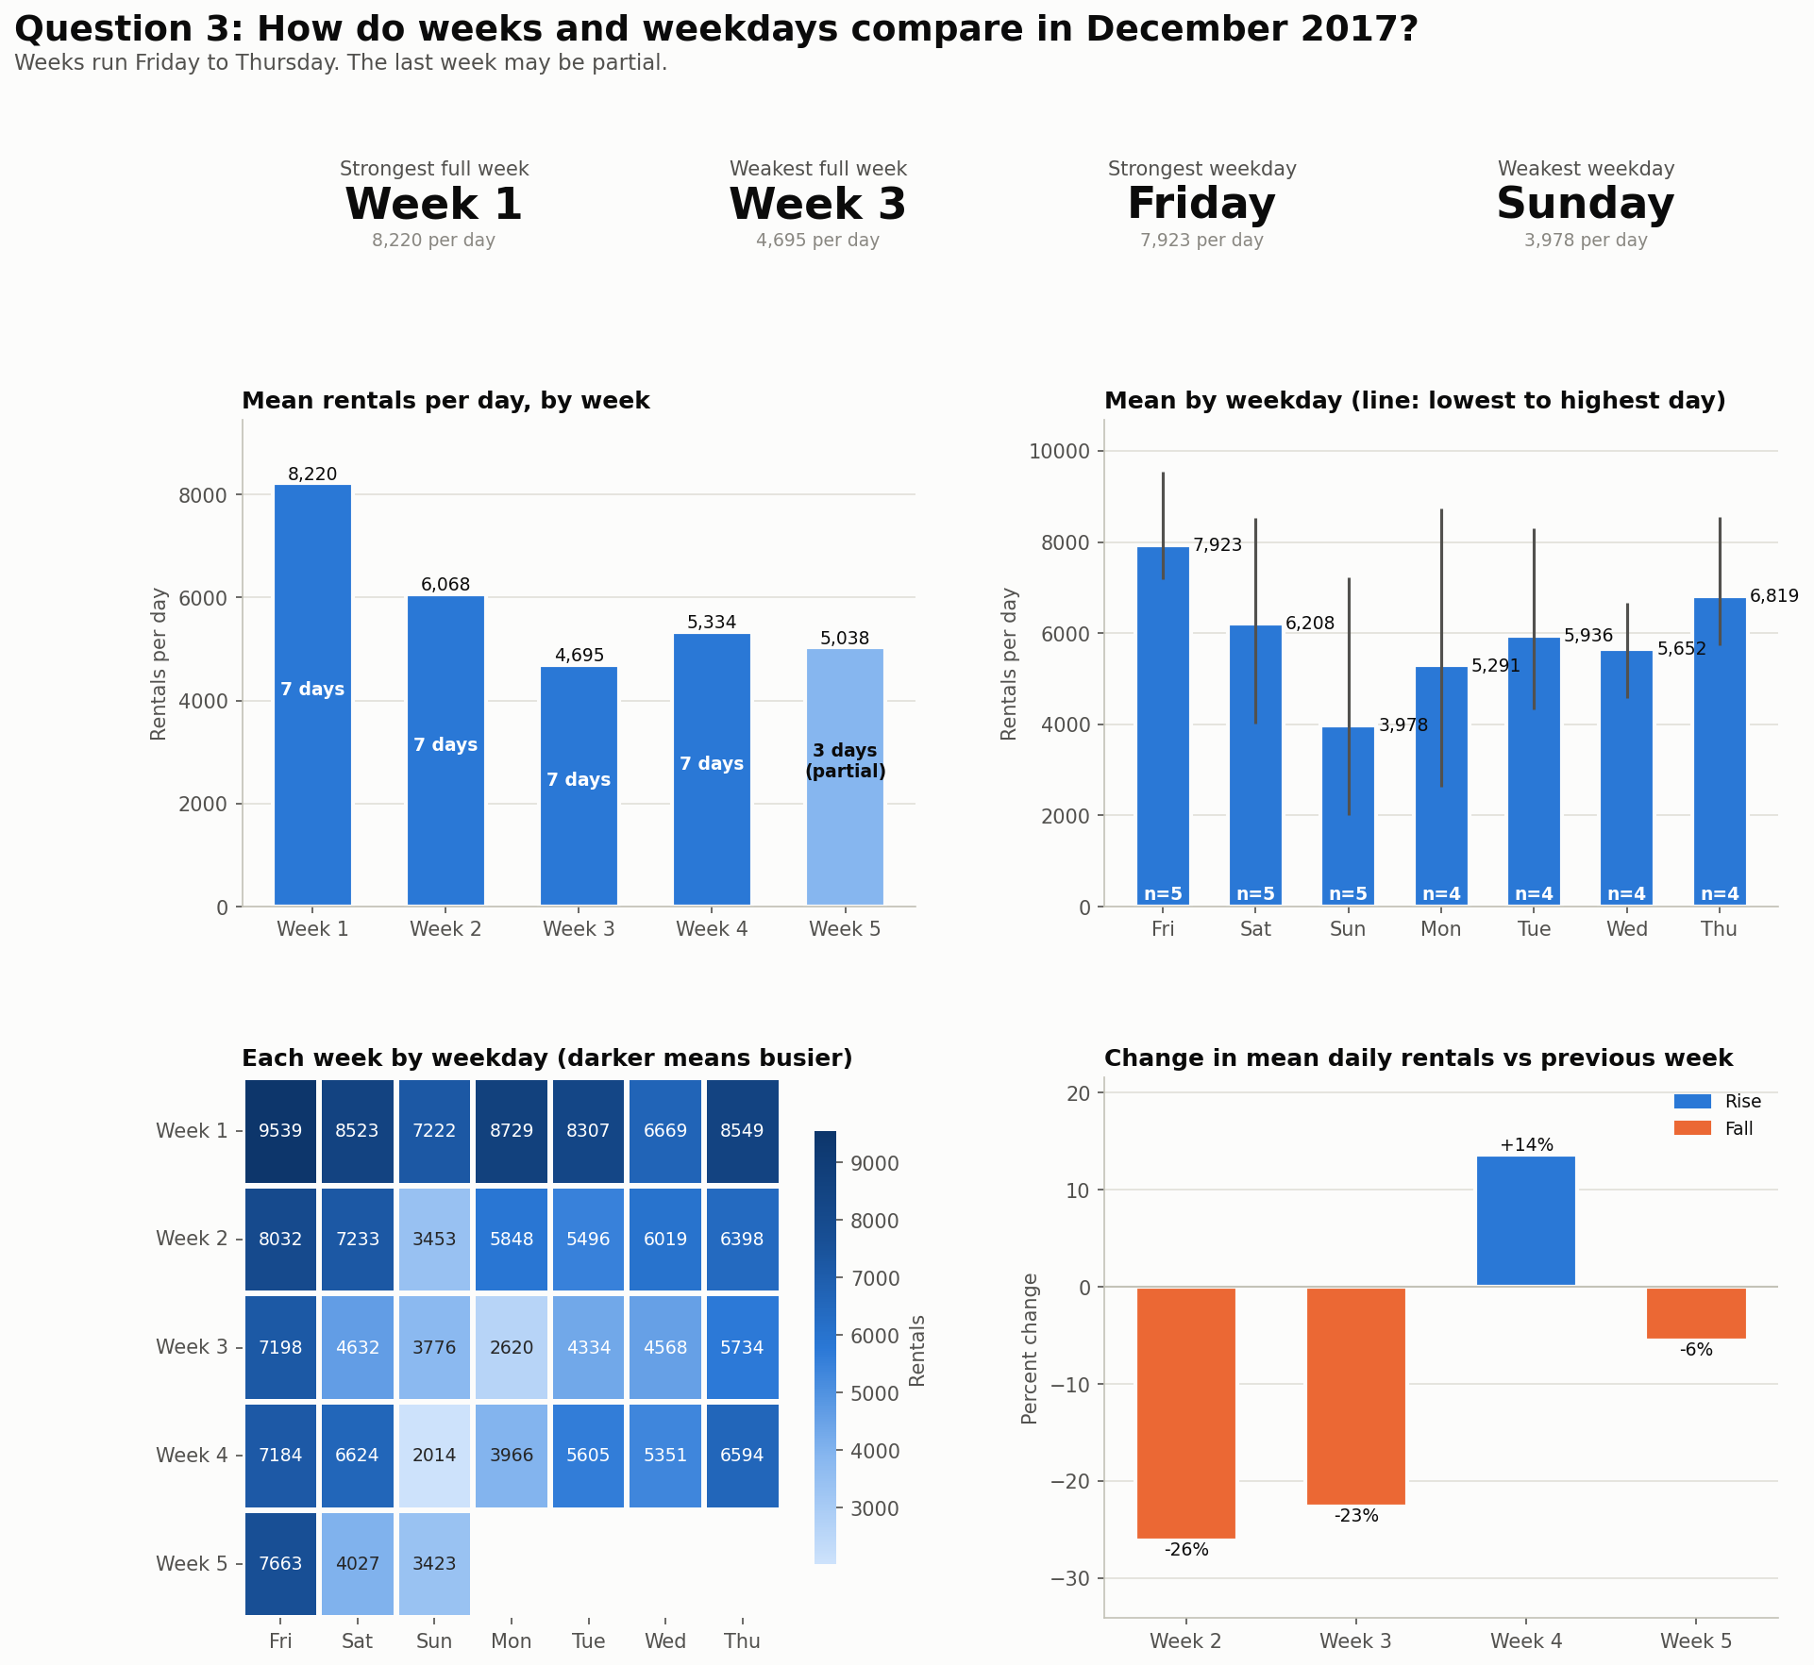
Figure 3. Comparison of week and weekday.

Week | Dates | Days | Mean per day | Change | Note
1 | 1 Dec to 7 Dec | 7 | 8,220 | n/a | Full
2 | 8 Dec to 14 Dec | 7 | 6,068 | -26% | Full
3 | 15 Dec to 21 Dec | 7 | 4,695 | -23% | Full
4 | 22 Dec to 28 Dec | 7 | 5,334 | +14% | Full
5 | 29 Dec to 31 Dec | 3 | 5,038 | -6% | Partial

- Mean daily rentals fell 43% from Week 1 (8,220) to Week 3 (4,695). Week 4 recovered to 5,334. Week 1 to Week 4 is a drop of 35%.
- Friday is the strongest weekday at 7,923 rentals per day. Sunday is the weakest at 3,978.
- Each weekday appears four or five times. Check the ranking against 2018 before calling this ranking a rule.
Answer. Demand fell from Week 1 to Week 3 and partly recovered. Friday leads and Sunday trails.

Question 4: Did weather explain the weak days?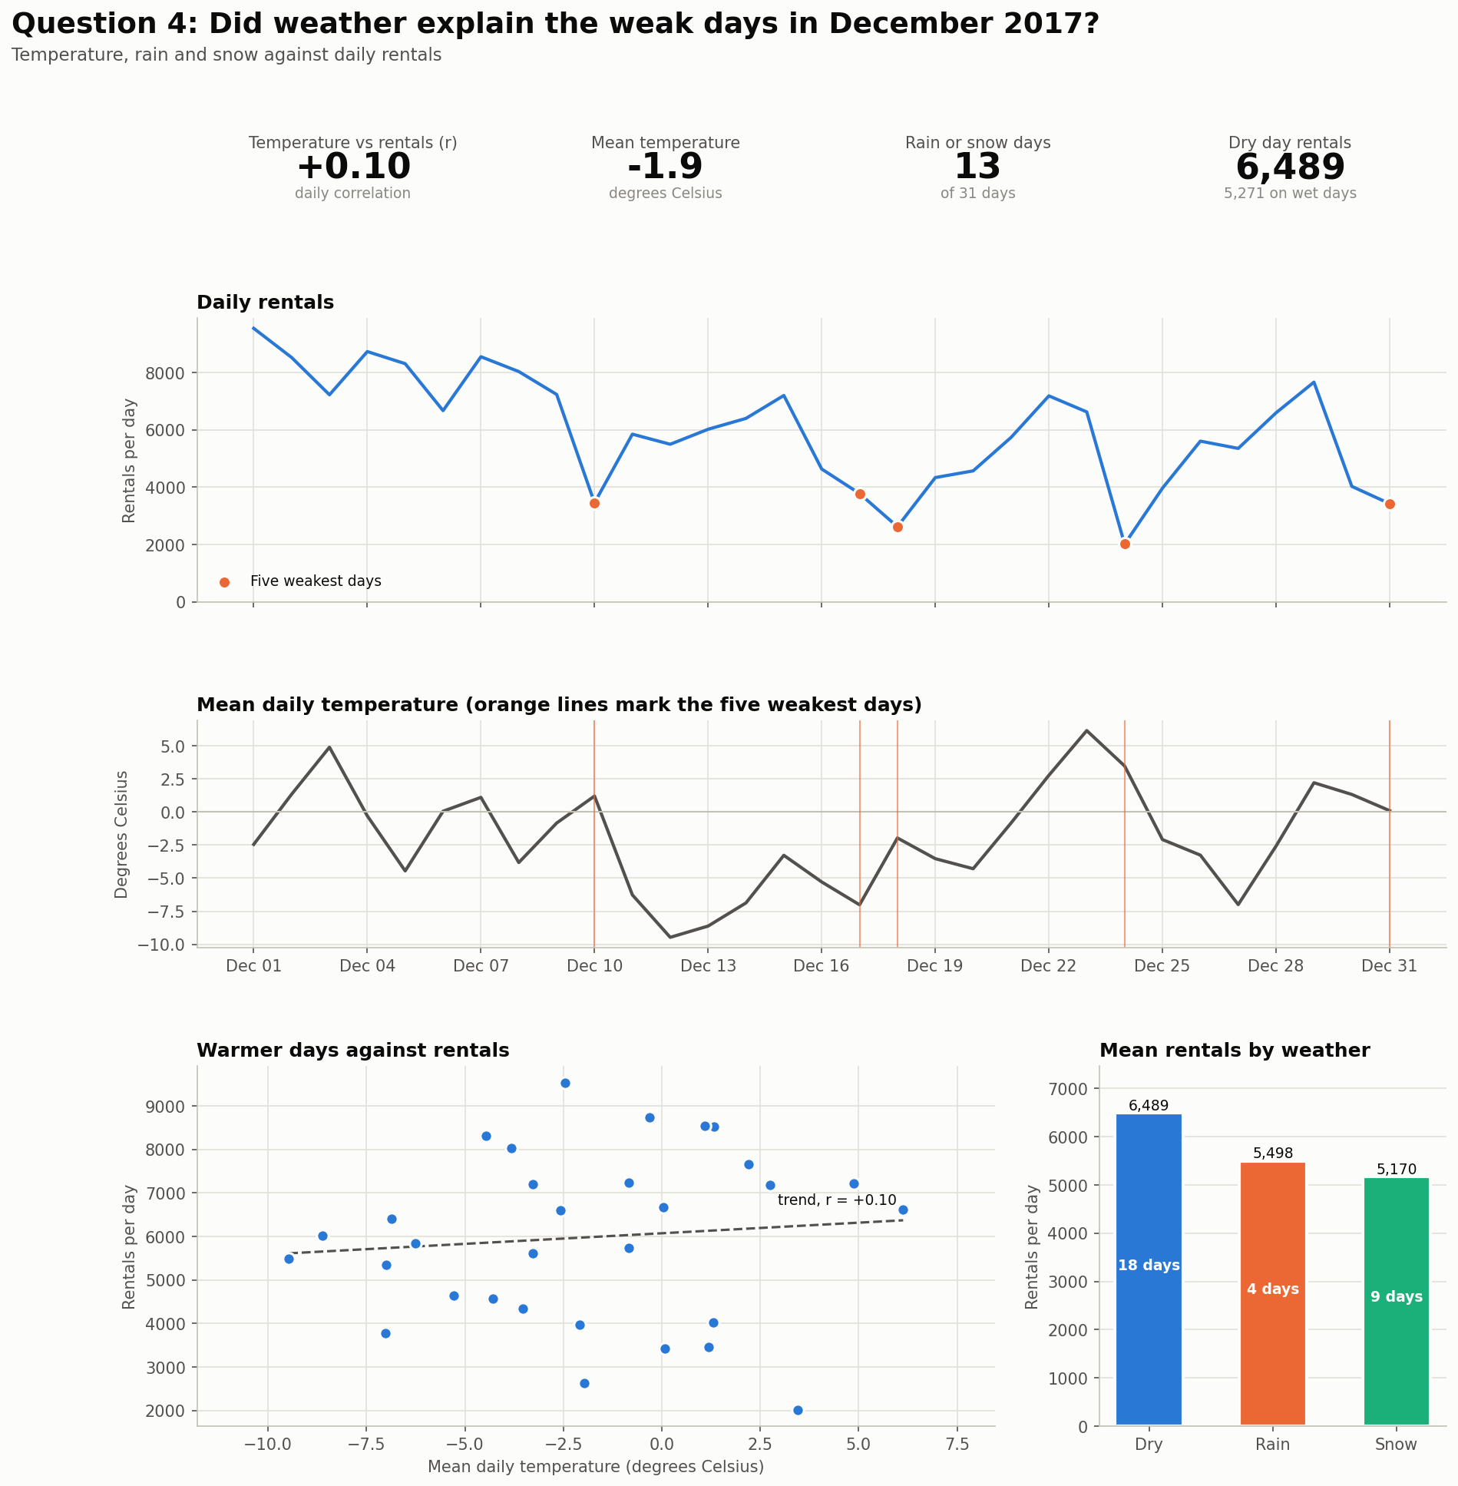
Figure 4. Rentals and weather on the same dates, with weather tests.
- Temperature against daily rentals gives r = +0.10. This is weak and sits below the 0.36 needed to separate from chance with 31 days.
- Rain fell on 9 days and snow on 9 days. Thirteen days had one or the other.
- Dry days averaged 6,489 rentals and wet days 5,271, a gap of 19%. On weekdays only, dry days averaged 6,838 (12 days) and wet days 6,048 (8 days), a gap of 12%.
- Four of the five weakest days were Sundays. The two weakest days both recorded precipitation: 24 December (20.0 mm of rain) and 18 December (59.7 cm of snow recorded).
- Snowfall readings summed to 202.5 cm in Week 3, the weakest week. Week 1 recorded 19.0 cm and Week 4 recorded 7.7 cm.
- Sunday 17 December was dry at −7.0°C and still ranked fourth weakest.

Answer. Temperature alone does not explain the weak days. Rain and snow days ran lower. Week 3 combined the heaviest snowfall with the lowest rentals. Day of week matters at least as much. With 31 days the data cannot separate the two.

Data Limitations
- One month. The report covers 31 days and five weeks. Each weekday appears four or five times.
- One season. Every row carries the Winter label, so the data cannot test a season effect.
- No operations records. The file holds no bike availability, repair, fleet or station data. Supply-side causes stay untested.
- No money data. The file holds no revenue or cost figures.
- Completed rentals only. The count shows finished rentals. Demand left unserved stays hidden.
- Weather and weekday overlap. Wet days and Sundays coincide on several dates. A correlation is a straight-line measure and does not prove cause.
- Holiday flag. The source flags four dates as holidays. This report uses 25 December only.
- No 2018 comparison yet. The 2018 report and the comparison report test whether these patterns repeat.

Business Recommendations
Recommendation 1: Review operations records for the December decline
Finding. Mean rentals per day fell 43% from Week 1 to Week 3, although Week 4 recovered to 5,334 per day from 4,695 in Week 3. The recurring Sunday dip also suggests a day-of-week demand pattern.
Action. Review bike availability records and maintenance or repair downtime records for 10 to 24 December. Separate the snowfall days (heaviest on 18 to 20 December) from the service days, so weather and operations do not blur together.
Expected result. The company learns whether service interruptions contributed to the decline and decides whether to change service or supply.
Data gap. The data confirms the drop in rentals and holds no operations records to establish their cause.

Recommendation 2: Move routine service to Sundays
Finding. Four of the five weakest days in December 2017 were Sundays. Sundays averaged 3,978 rentals per day against 5,978 for the month, a gap of 33%.
Action. Schedule routine servicing and repairs on Sundays. This keeps bikes ready for Friday, the strongest day at 7,923 rentals per day.
Expected result. The company compares rentals and repair downtime before and after a Sunday service window over several weeks.
Data gap. The finding rests on five Sundays. The file holds no repair, fleet or cost records.

Recommendation 3: Protect the weekday peak hours
Finding. On all 20 weekdays outside the holiday, the busiest hour was 8:00 (15 days) or 18:00 (5 days). Weekday rentals average 618 per hour at 8:00 and 570 at 18:00.
Action. Stock bikes at stations before 8:00 and 18:00 on weekdays. Keep servicing out of 7:00 to 9:00 and 17:00 to 19:00.
Expected result. The company tracks unavailable bikes in these windows and compares them with rentals.
Data gap. Rentals count completed trips only, so unmet demand stays hidden. The file holds no station data.

Conclusion
Seoul Bike Rentals saw 185,330 rentals in December 2017. Demand fell 43% from Week 1 to Week 3 and partly recovered in Week 4. Weekdays follow a commuter pattern with peaks at 8:00 and 18:00. Sundays are the weakest day. Weather shows a weak link with temperature and a suggestive link with rain and snow.
The data shows what happened and does not show why. The three recommendations test causes before the company acts. The 2018 report checks whether the patterns repeat. The comparison report sets the two periods side by side.

